Pages 77 -93 ***Java Programming A Comprehensive Introduction***

Page 893

**What is the if / else ladder?**

 a secondary path of execution when an "if" clause evaluates to false.

**What is a nested if?**

using one IF Function inside another

**Switch-(Pg.84 in Java Programming)-**

**switch** (*expression*) {

**case** constant 1:

*statement sequence*

**break**

**How does break work differently in a switch statement after a case statement, than in a normal conditional statement?-**

Break can exit the swtich statement

**Format Specifier-** the sequence passed as the formatting string argument; "Characters matched" gives the format of the sequence sought or printed, with a hyperlink to the section on literals which applies to that format;

**" %.2f "- Describe what the statement is saying-**

Print 2 decimal

**“%n”- Describe what the statement is saying-**

Next line

**System.out.format("%.2f%n", b + a); // Example of code**

**System.out.format(…); Explain how this method differs from System.out.println**

The system.out.format consists of static text embedded with format specifiers; except for the format specifiers, the format string is output unchanged. And the System.out.println only print what inside the parenthesis.

**Programming Assignments**

**1st Task:** Create a program that uses a **switch** statement and **case** statements to calculate the number of days in any given month based upon a users input.

February is a unique month. So the **case** for February will needa **if**… **else** to capture the two possible options for the number of days in February based upon leap year.

Hint***. You will need to use some of the code from Assignment 4, Task 3.

Use the **new** Scanner (System.in); method for input. Make sure the program can deal with any integer input. If a number entered does not correspond to a month of the year print “Invalid Month.”

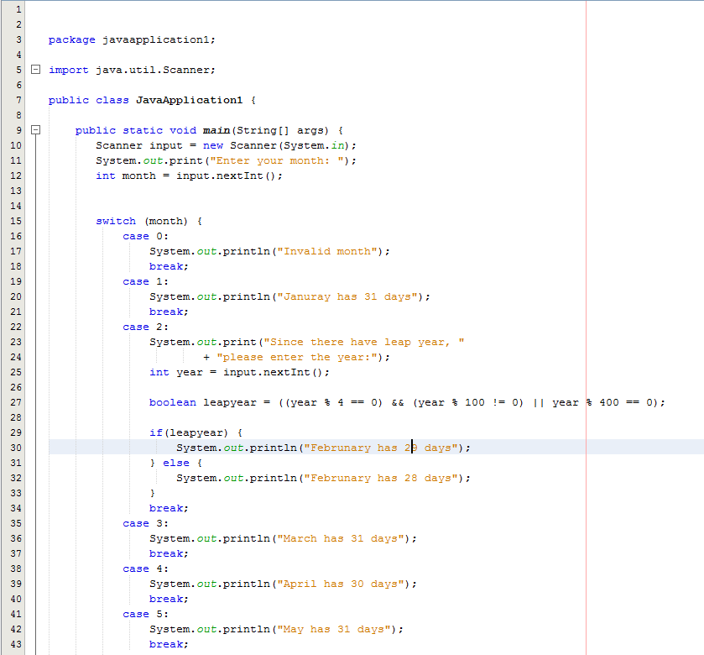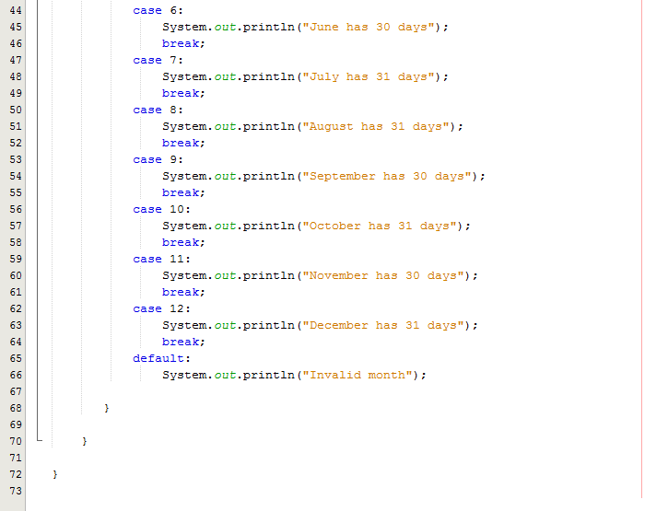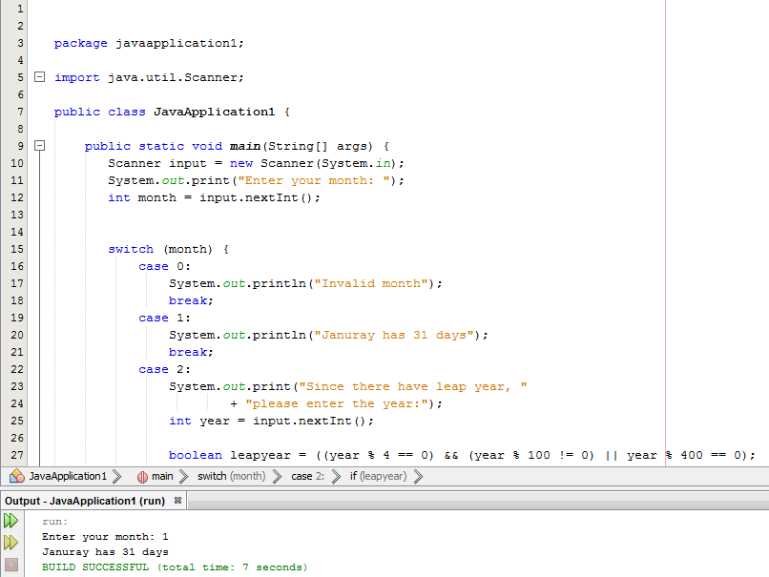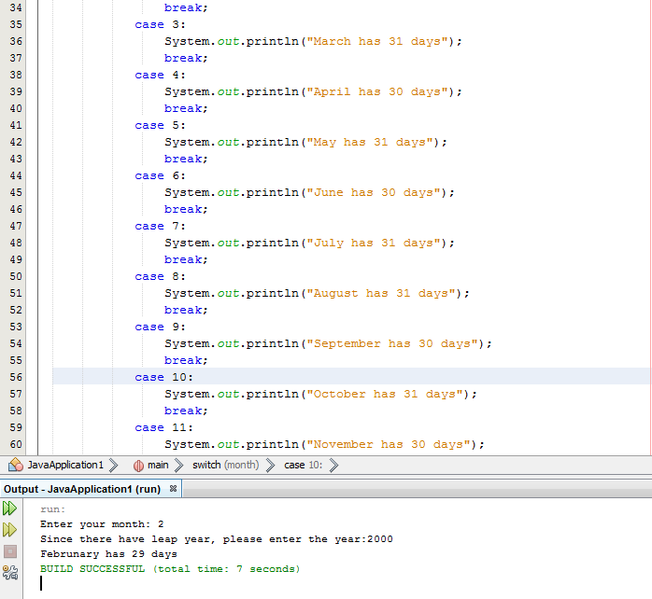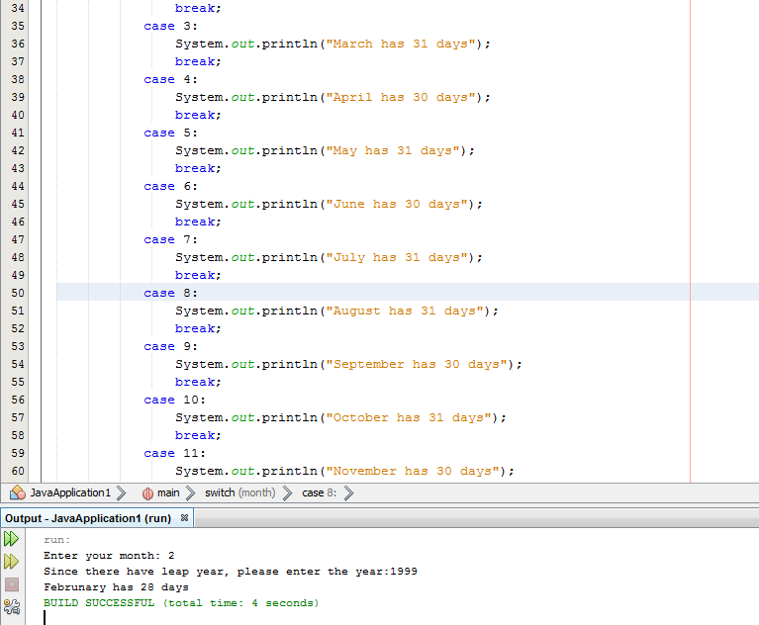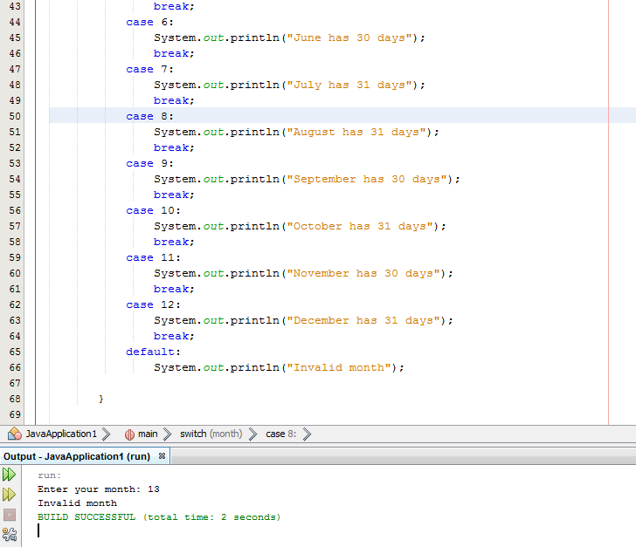

**2st Task:** Using **If** and **else** ladder. Write a program that computes a single filer’s income tax burden.

|  |  |
| --- | --- |
| **TAX RATE** | **Single Filers Income** |
| 10% | Up to $6000 |
| 15% | $6,001 - $27,950 |
| 27% | $27,951 - $67,700 |
| 30% | $67,701 - $141,250 |
| 35% | $141,251 - $307,050 |
| 38.6% | $307, 051 or more |

The user should be able input his data into a JOptionPane.showInputDialog “pop up box”

The output can be a simple system.println output.

**Sample Output- //**Output should have proper formatting for dollars, 2 decimal places

Income tax for a single person making $85000.00 is $25500.00

Income tax for a single person making $9800.00 is $1470.00

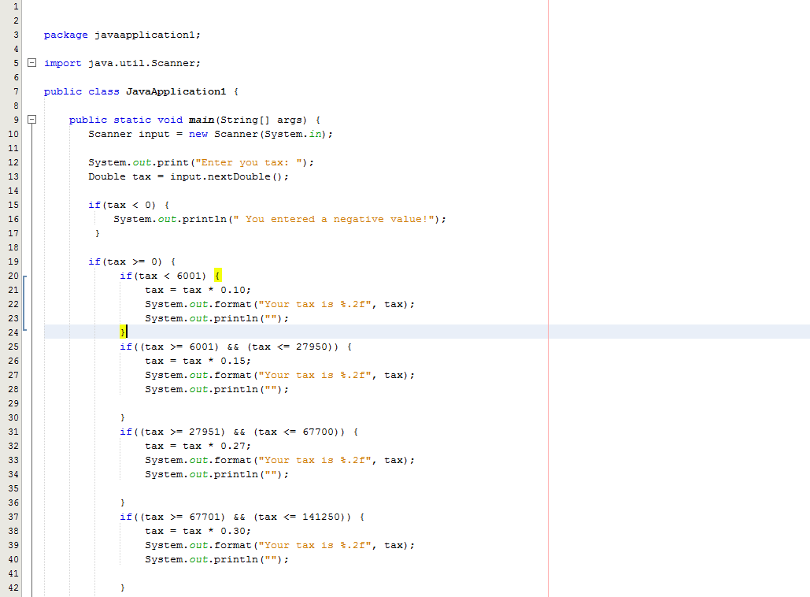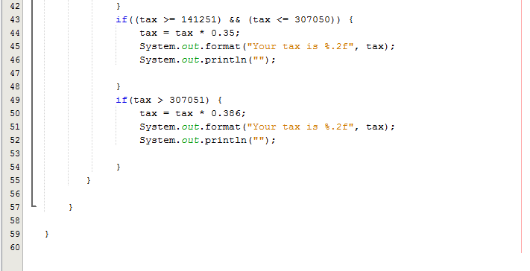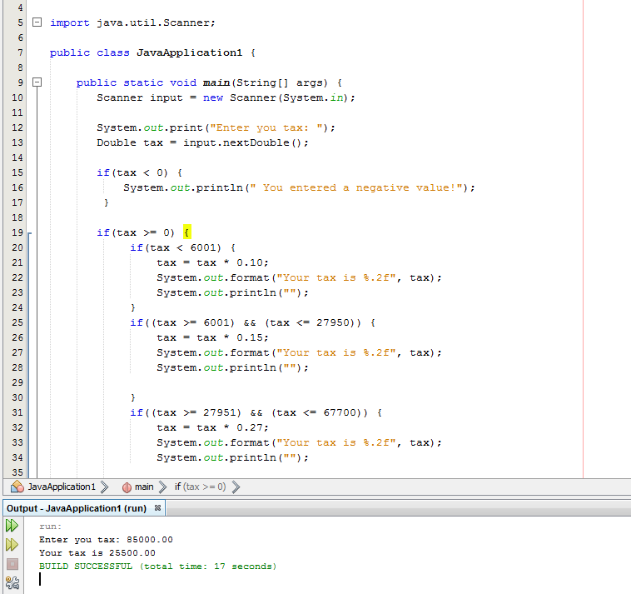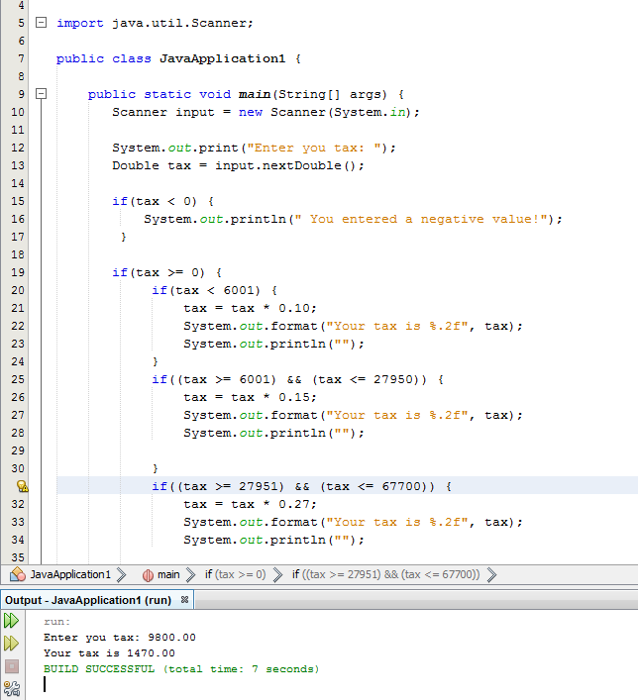

3rd Task**-** Write a program that prompts a user to enter the points earned for a course and determines the grade based upon the following scale.

0 – 59 is a F **Print:** Try Harder

60 – 69 is a D **Print:** Try Harder

70 – 79 is a C **Print:** OK

80 – 89 is a B **Print:** Good

90 and greater is an A. Print: Excellent

Use the **If / Else** ladder to create the source code. Use **switch** statements to print the message strings.

The user should be able input his data into a JOptionPane.showInputDialog “pop up box.”

